Coursework – Data Visualization
40213297
SET09120
Abstract. In this report, I am shortly presenting seven relationships found by me with the use of data visualization in the supplied dataset. The first relationship represents the comparison of overall scores, where location D scored the highest. The second relationship shows how female athletes are gradually getting better at jumping, older they get. The third relationship shows that people over 30s are better at distance running than younger athletes. The fourth relationship shows that in location E teenage females who have high scores in distance running, are worst in jumping. The fifth relationship shows that athletes in locations A and C who are good at sprinting, are bad at throwing. In my sixth relationship athletes from location A and C who are bad at jumping are having high overall scores. In my last, seventh relationship male athletes from location B shows that athletes over their 30s are getting higher scores in distance running and jumping, while younger athletes who are good at jumping are getting lower scores in distance running. At the end I am focusing on producing and describing an optimized representation of the most interesting for me relationship, which is relationship number seven.
Keywords: Data Analytics, Coursework, Data Visualization
- Description of found the relationships
  - First relationship
In the comparison of overall scores between locations, location D has the highest score. This is very visible on Figure 1, where boxplot diagram representing mentioned comparison, has higher scores and higher median for location D. In order to find this relationship, I used a ggplot function in R-Studio with use of R language to create boxplot, with locations on the x-axis and overall score on the y-axis. This relationship means, that D gained the highest scores from all the locations in overall.

  - Second relationship
The second relationship which I found in the supplied dataset, is the relationship presented in Figure 2.
On this diagram, I compared with use of jitter-plot female and male scores in jumping for all locations and all ages. As it’s showing in Figure 2, female athletes, with age, are getting gradually higher scores. Female teenagers on the diagram have the lowest scores and female athletes over their 30s have the highest scores. On the x-axis, for more visible comparison, I set as a variable gender of the contestants and on the y-axis, I set as a variable their scores in jumping. This shows, that older women are getting, they are also becoming better in jumping.

  - Third relationship
The third relationship represents (see Fig. 3) the difference between contestants of different age groups in their scores for distance running. On this diagram people in group age categorized as over 30 years old have the highest scores, compared to representants of the younger ages. The presented relationship shows then, that older men and women over their 30s are getting much higher and more consistent scores in distance running, in comparison to younger ages.

  - Fourth relationship
Fourth found by me relationship is represented in Figure 4.
In this relationship, teenage female athletes from location E have higher scores in sprinting, but lower in jumping. On the beginning their scores - represented by the black line of dots - are similar to their scores in jumping, but higher they are scoring in sprinting, their jumping scores keep getting smaller. This shows that teenage female athletes from this location who are much better at sprinting are bad at jumping.

  - Fifth relationship
To show the fifth relationship, I decided to compare scores in throwing and sprinting in all locations (see Fig.5). The scores in locations A and C for both females and males are showing a relationship where athletes who scored the highest score in sprinting have also the lowest scores in throwing. The reverse of this relationship we can see, when we look at athletes who scored the highest in throwing – their scores in sprinting are very low, with equal to 0 points in sprinting for those, who scored perfect 100 points in throwing.

  - Sixth relationship
In Figure 6 I compared overall scores of male athletes in different locations with their scores in jumping presented on the x-axis. In locations A and C those scores are creating very similar to each other line, especially when in compared with scores in different locations. Basing on this diagram, I was able to see that athletes in locations A and C, who have the lowest scores in jumping, have a higher overall score, above 25 points. On the other side, athletes who scored 100 points in jumping, have only a slightly higher overall score – above 60 points. In other locations, for comparison, those scores are much less connected with each other.

  - Seventh relationship
My seventh relationship is represented in Figure 7, where I decided to have closer look at male scores in location B, with their scores in distance running on y-axis and their scores in jumping on the x-axis. As is presented on the diagram, their scores create together a curve, which shows how works relationship between their scores in these two disciplines. Athletes from location B, which are younger than 30 years old, are having high scores in jumping, but low in distance running. For example, when they score is equal to 80 points in jumping, their score in distance running is equal to 0.
Athletes in different ages (teenagers and over 20s) are represented by the dark blue and black dots on the diagram. I decided to make their scores more visible by simply setting the size of the points to be higher. I could see that athletes in this age have their scores similar to those athletes who are in their late 20s. Their max. score in distance running is above 75 points and 50 points for jumping, while if their score in jumping is equal to 80 points, then their amount of points in distance running is equal to 0.
- Most interesting relationship
In this section, I would like to focus on the seventh relationship, which in my opinion is the most interesting from all of them.
The Figure 7, which is visual representation of seventh relationship, shows scores in jumping and distance running for male athletes in location B. To better visualize this relationship, I decided to narrow my search only to one location and one gender, as female athletes from same location had different scores, which didn’t show any kind of relationship. I used scatterplot diagram, as it’s the best way to show a non-linear pattern and allow to easily determine the maximum and minimum value.
Thanks to the use of scatterplot I was able to show the difference in scores between ages in more visible way and find more facts about this relationship. Moreover, it allowed me to represent in better way scores of athletes in different ages. I set point size of them to be slightly apart and different color than for other ages, thanks to which, they are visible on this diagram.

Fig. 1. 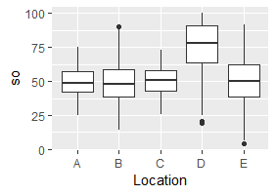

Fig. 2. 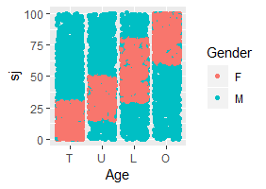
Fig. 3. 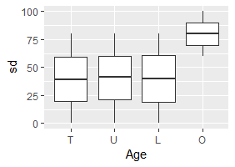
Fig. 4. 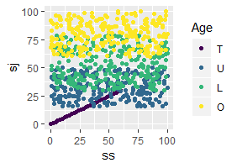
Fig. 5. 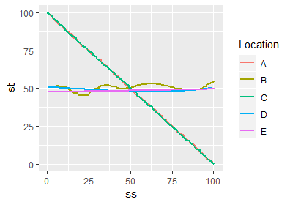
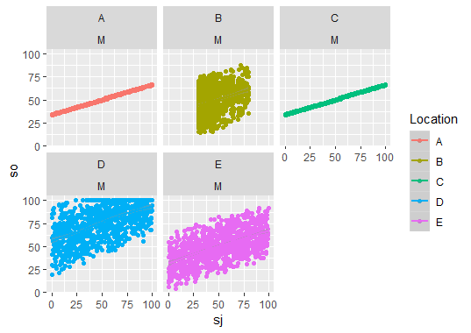
Fig. 6.
Fig. 7. 